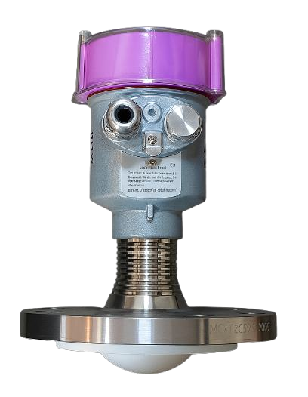

RADAR Level Transmitter for Liquid Application
Model: FMLT -1800LS

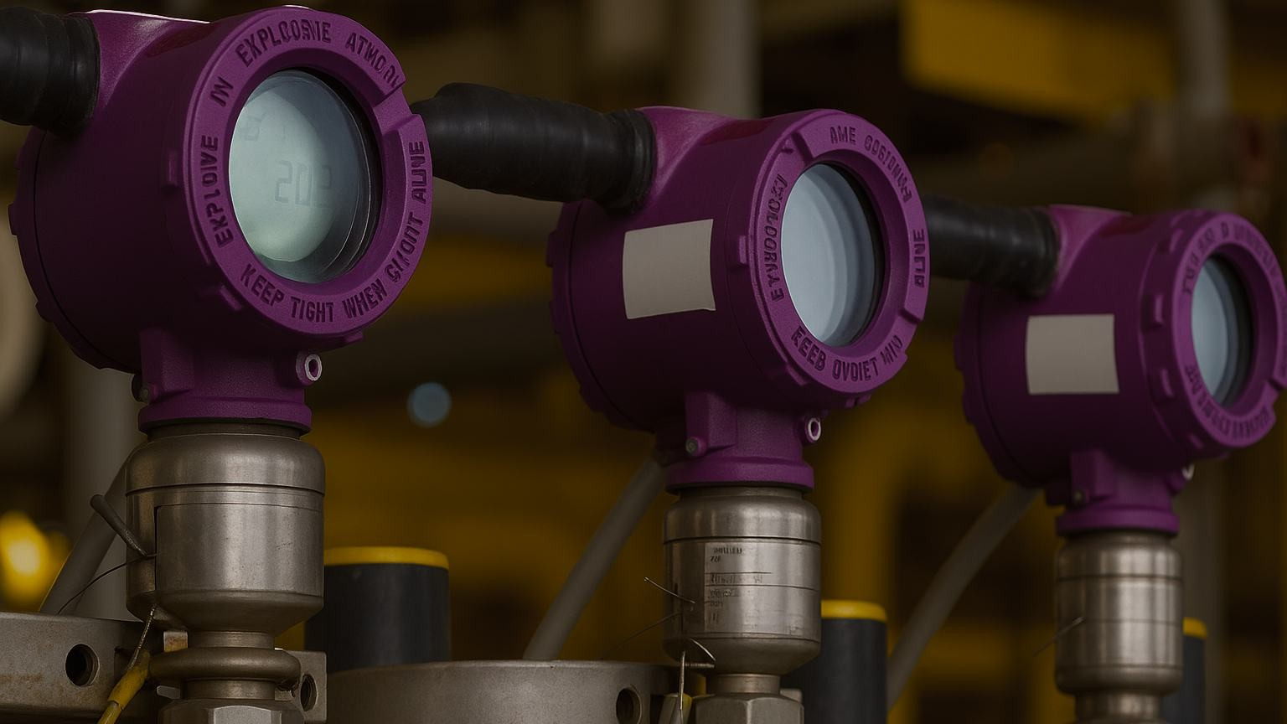



Levtron Instruments Pvt Ltd

Office No 2, 1st floor, plot no 6,
Pandhari Industrial Estate,
Shivane. Pune 411023,
Contact: 09579430012,
9730042725,
E-mail: sales@levtron.in;
Web : www.Levtron.in
WEB : www.levtroninstruments.com
Catalog
- Product Introduction 1
- Technical support 2
- Structure drawing 3
- Installation 6
- Install | INSTALL 9
- Instrument operation 10
    - Basic setting menu operation 14
      - [High low adjustment] 14
      - 【 Range setting 】 15
      - 【 Blind zone setting 】 16
      - [Damping time] 16
      - Medium Type 17
      - Vessel type 18
    - Advanced setting menu operation 19
      - [False echo learning] 19
      - Distance Offset 20
      - [Bus address] 20
      - 【 Output mode 】 20
      - 【 Current simulation 】 21
      - 【 Current function 】 21
    - Service Menu Operation 22
      - [Echo rate] 22
      - [Window Setting] 22
      - 【 Echo proportion 】 23
      - 【 Echo locking 】 23
      - 【 Primary filtering 】 23
      - [Secondary filtering] 24
      - [Response rate] 24
      - [Threshold Setting] 24
    - Display menu operation 25
      - 【 Display mode 】 25
      - [Unit of measurement] 25
      - Language 26
      - 【 LCD contrast 】 26
7 Appendix: Glossary 27

Product Introduction

characteristic

76-81GHz frequency modulated continuous wave (FMCW) radar products support four wire system and two wire system applications.For multiple models, the maximum range of the product can reach 120m, and the blind area can reach 10cm.Because of its higher working frequency and shorter wavelength, it is particularly suitable for solid applications. The working mode of transmitting and receiving electromagnetic waves through lenses has unique advantages in high dust and harsh temperature environments (+200 ℃ ).The instrument is provided with flange or thread fixing mode, which makes the installation convenient and simple.

The main advantages of this series are as follows:
- Based on the self-developed CMOS millimeter wave RF chip, a more compact RF architecture, a higher signal-to-noise ratio, and a smaller blind area are realized.
- 5GHz working bandwidth enables the product to have higher measurement resolution and accuracy.
- The narrowest antenna beam angle is 3 °, the interference in the installation environment has less impact on the instrument, and the installation is more convenient.
- The wavelength is shorter and has better reflection characteristics on the solid surface, so it does not need to use a universal flange for aiming.
- Support Bluetooth debugging of mobile phones to facilitate the maintenance work of on-site personnel (future versions will support ★)

technical support
Technical specifications of technical support level meter
Transmission  frequency | 76GHz~81GHz, FM scanning frequency width 5GHz
measuring  range | 35m 85m 120m
measurement  accuracy | ±1mm
Beam angle | 3°、8°
Range of  dielectric constant used | >=2
Power supply  range | 18~28.0VDC, four wire system (<1W)
Communicatio  n mode | HART/MODBUS bus
signal output | 4~20mA or RS-485
Industrial temperature/  humidity | -4~85℃/≤95%RH
Shell  material | Aluminum alloy, stainless steel
Antenna type | Lens antenna, which can be equipped with lens antenna shield/anti-corrosion antenna/antenna cooling  paste/quartz isolation flange
Process  pressure | -0.1~2MPa
Product size | Ø100*270mm
Cable entry | M20*1.5
Recommended  cable | AWG18 or 0.75mm²
Protection  grade | IP67
Installation  mode | Thread or flange
Net  weight/gross weight | 2.480Kg/2.995Kg

Structure diagram
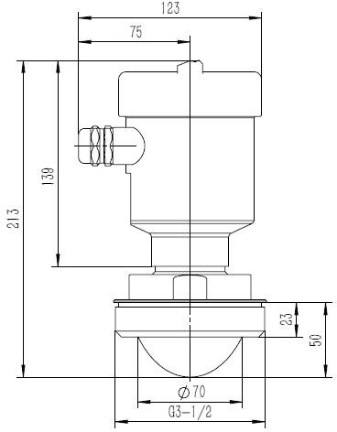
Schematic diagram of pipe thread process connection at room
temperature
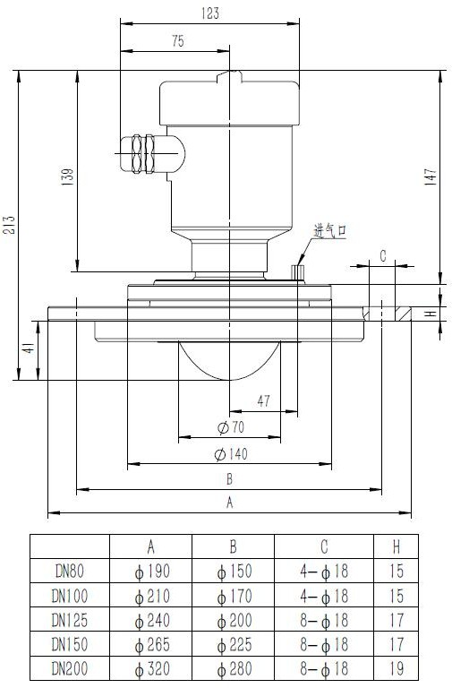
Dimension Diagram of Universal Flange Universal High
Temperature Structure

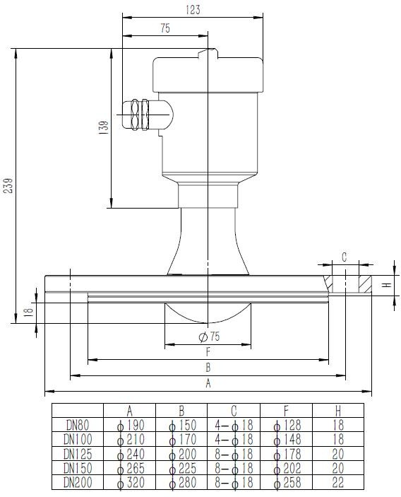
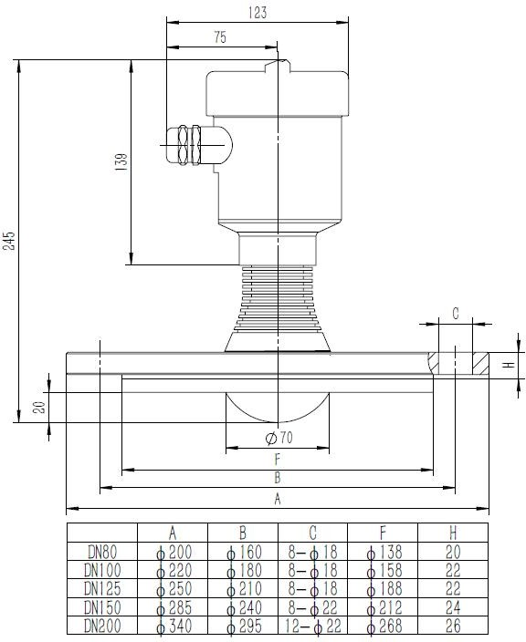

Schematic Diagram of High Temperature and High Pressure Structure Dimension of Anticorrosive Flange

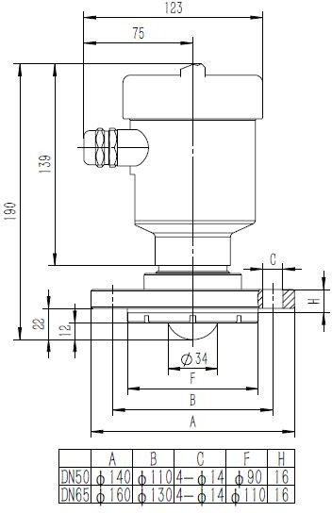
Structural dimension diagram of anti-corrosion flange under normal temperature and pressure

install

Two points to pay attention to during installation: (1) aim at the target material level and try to ensure the vertical incidence of the material level;(2) Avoid false echoes.See the following points for typical working conditions.
Ensure that there are no interfering objects, such as ladders and steps, within the beam range.
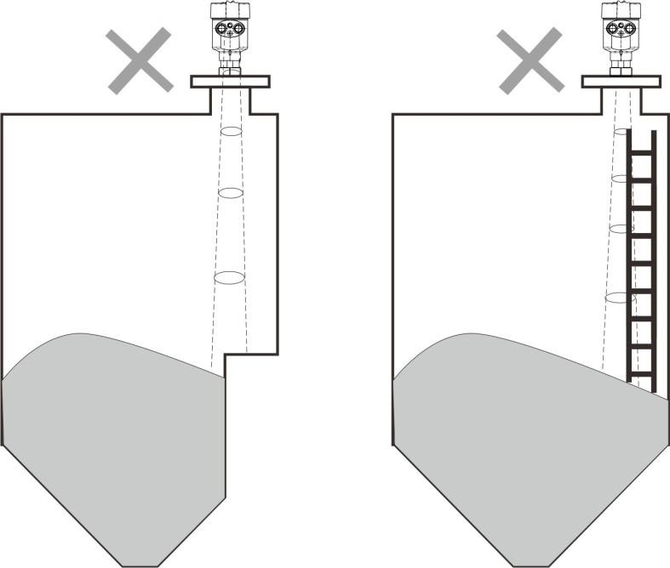
Schematic diagram of instrument installation position
The instrument installation shall ensure that the antenna beam avoids the feed inlet, as shown in the figure.

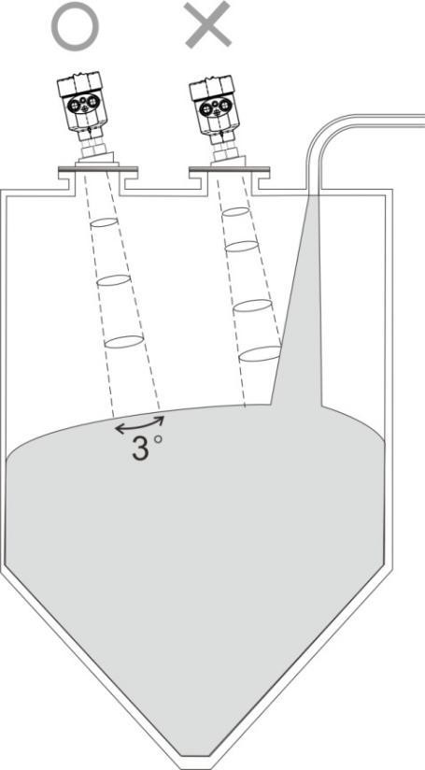
Antenna beam avoids the feed inlet

The instrument shall be installed at least 20cm away from the vessel wall, otherwise it is likely to produce wrong readings.
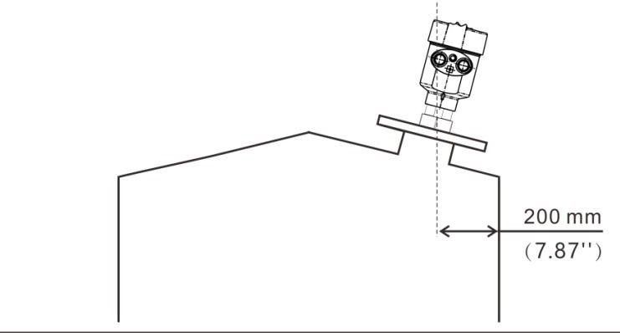
The installation shall be at least 20cm away from the vessel wall

The conical container shall ensure that the beam is directed at the tank bottom as far as possible, otherwise the measurement results at the tank bottom may be inaccurate

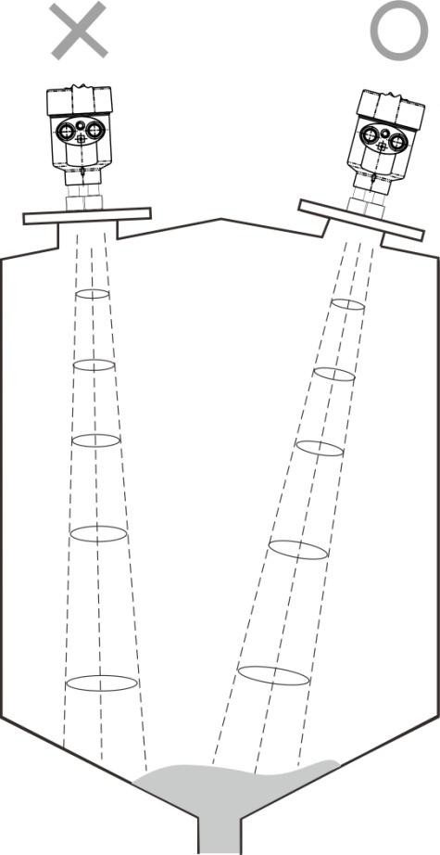
The conical tank shall ensure that the beam is directed at the tank bottom as far as possible

Install | INSTALL

Connection

  - Single chamber housing 24VDC product wiring diagram

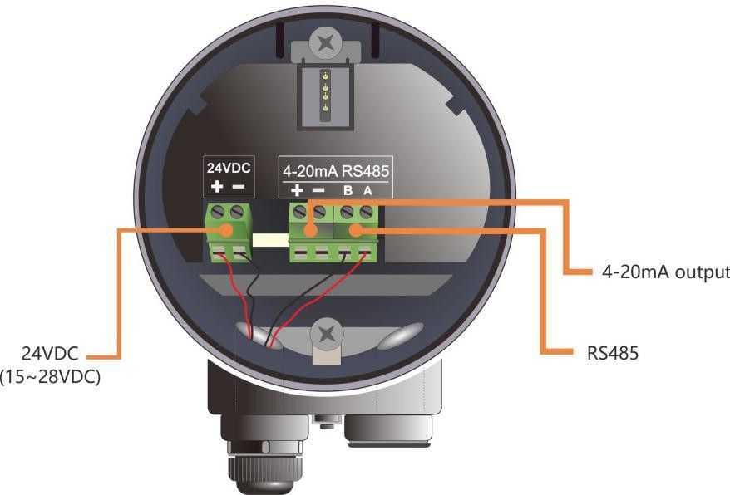
Figure 24VDC product wiring diagram of single chamber housing

24VDC power supply product interface description

Instrument 24VDC power supply product interface description
PIN1 | Positive end of 24VDC (+) power line
PIN2 | Negative terminal of 24VDC (-) power line
PIN3 | HART (+), i.e. 4-20mA (+), 4-20mA current output positive terminal
PIN4 | HART (-), i.e. 4-20mA (-), 4-20mA current output negative terminal
PIN5 | RS485 (A), 485 communication output
PIN6 | RS485 (B), 485 communication output

Instrument Operation

Key description
The product display module consists of 4 keys and 128×64 dot matrix display. The display system has four display interface modes:
[Run Mode]: display the system operation status and current measurement data [Echo Mode]: display the echo condition currently measured by the system
[History Curve Interface Memo Mode]: display the historical measurement data recorded by the system operation
[Setup Mode]: set various data parameters for system operation
[Input Mode of input data interface]: input parameter values, numbers or characters The functions of the 4 keys are different in different display modes

Description of operation measurement interface

surface6 – 1Description of key functions when running the measurement interface
tagging | function | keyboard
① | -Switch to enter the parameter setting  interface | OK
② | -NULL
③ | -NULL
④ | -Switch to the echo curve interface | 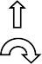  BK
- The running measurement interface is shown as follows.

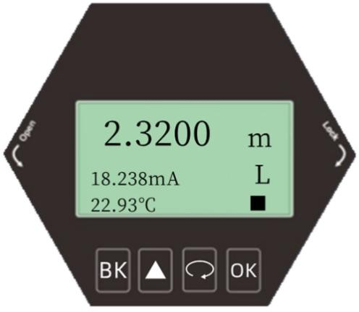
Schematic diagram of operation measurement interface

Echo curve interface description

taggin  g | function | keyboard
① | -Switch to the operation  measurement interface | 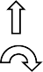  OK
② | -NULL
③ | -Show/hide threshold curves
④ | -Segment display of echo  curve | BK

In the operation measurement interface, press [BK] to enter the echo curve interface

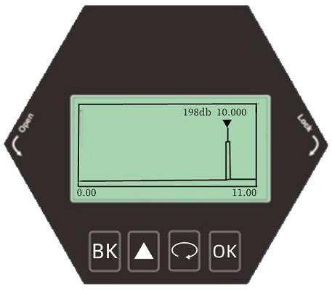
On the echo curve interface, press the [BK] key to switch from the echo curve interface to the operation measurement interface.

In the echo interface, in particular:
198db figure indicates the maximum echo intensity within the range. For a good metal reflector, the echo intensity should be about 220dB. If the echo intensity is less than 70dB, it indicates that the echo signal is weak, and technicians need to conduct corresponding troubleshooting.

Description of parameter setting interface
Function description of keys in parameter setting interface
taggin  g | function | keyboard
① | -Switch to the operation  measurement interface | BK
② | -Move the selected item up
③ | -Move selection item down | 
④ | -Enter the selected item sub  interface | OK
From the operation measurement interface, press [OK] to switch to the parameter setting interface, as shown in the following figure:

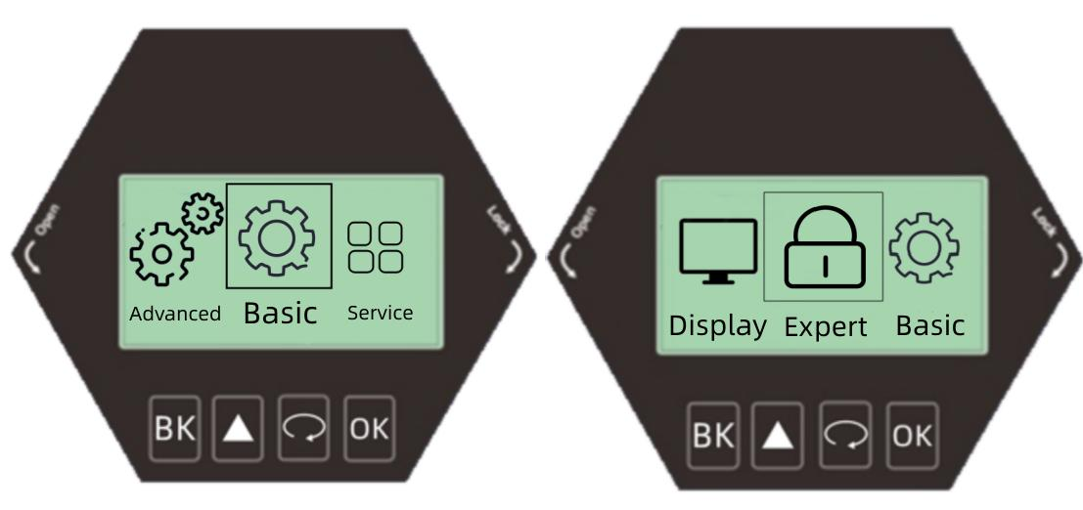

Basic Settings
The Basic Setting menu item can realize multiple functions, as shown in the following table.Through these parameter settings, the level meter can be quickly started.Select [Basic Setting] and press [OK] to enter the options interface. The options list is shown in the following table:

Basic Setup Menu Options

Default  Location | menu item
• | High low setting
 | Range setting
 | Blind zone setting
 | Damping time
 | Media Type
 | Container type

Advanced Settings
Select [Advanced Settings] and press [OK] to enter the options interface. The options list is shown in the following table:
Advanced Settings Menu Options
Default Location | menu item
• | False echo learning
 | Distance Offset
 | Bus Address
 | output location
 | Current simulation
 | Current function

[Services]
Select [Service] and press [OK] to enter the options interface. The options list is shown in the following table:
Service Settings Menu Options
Default Location | menu item
• | Echo rate
 | Window Settings
 | Echo proportion
 | Echo locking
 | Primary filtering
 | Secondary filtering
 | Response rate
 | Threshold setting

Display
Select [Display] and press [OK] to enter the options interface. The options list is shown in the following table:
Show menu options
Default Location | menu item
 | Measurement mode
 | Distance unit
 | language
 | LCD contrast

  - Operating Instructions for Menu Options

Basic setting menu operation

      - [High low position adjustment]

Press [ ] to enter the basic menu option [High Low Adjustment] [High/Low Setting] involves range setting. It maps the corresponding relationship between measured value and current output (4-20mA) together with [High Adjustment].In the [Basic Setting] menu, select [High and Low Position Adjustment], press [OK] to enter [High and Low Position Adjustment], press [OK] to complete the editing operation, and press [BK] to exit.
        - [High and low position setting] The high position corresponds to the full position, and the low position corresponds to the empty position, as shown in the following figure.

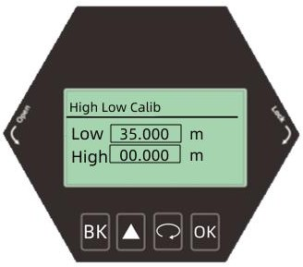

Low position adjustment editing interface and definition

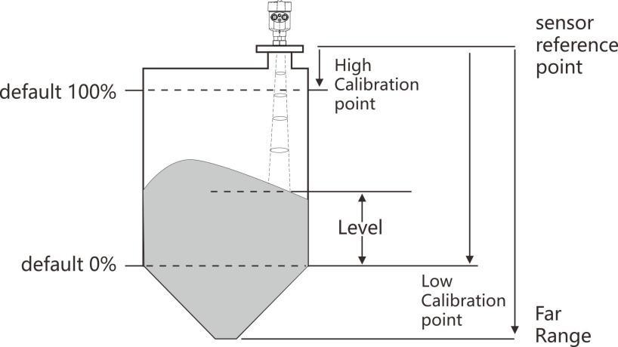

      - [Range setting]
Press [ ] to enter the basic setting menu option [Range setting]
In order to get the correct results, it is necessary to set the measuring range of the instrument.Select the [Basic Setting] menu and enter the [Range Setting] option. If you need to modify the value, press the [OK] key to complete the editing operation.Press [BK] to exit.
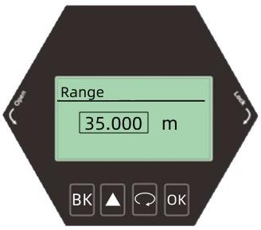

Parameter  name | range
Parameter  range (m) | 1~85 | 1~35 | 1~120
Default value  (m) | 85 | 35 | 120
Associated  configuration | （1） Blind zone: if the set range value is less than (blind zone+0.5), the range is automatically set to (blind

zone+0.5)
（2） 4mA corresponding position,
When the current output function is distance, the corresponding position of 4mA corresponds to the measuring range and is modified at the same time; Set quantity relationship:
Blind zone+0.5<=range
Option  meaning | The echo area greater than the range is not selected
Special  matters | nothing

      - [Blind zone setting]
Enter the [Basic Setting] menu, select [Blind Zone Setting], and press the [OK] key to enter the option editing blind zone range, as shown below.To modify the value, complete the editing operation according to the keyboard menu.

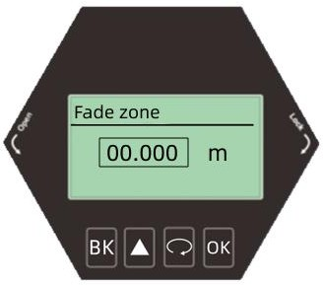

Blind zone setting and editing interface Description of blind area
 | 85m (solid) | 35m (liquid) | 120nm (solid)
Parameter name | blind area
Parameter range  (m) | 0~(range - 0.5) | 0~(range - 0.5) | 0~(range - 0.5)
Default value (m) | 0 | 0 | 0
Associated configuration | （1） If the value set for the blind zone is greater than (range - 0.5), the blind zone is automatically set to (range - 0.5)
Option meaning | The echo area smaller than the blind area is not selected
Special matters | nothing

      - [Damping time]
In order to improve the stability of the measured output value, a larger [damping time] can be set to achieve the stability of the measured value and increase the anti-interference ability.For example, if the damping time is 2 seconds, the measured object position will change step at time t.

The measured output value will follow the actual position of the measured object 10 seconds later, enter the [Basic Setting] menu, select [Damping Time], press [OK], and the display is as shown below:
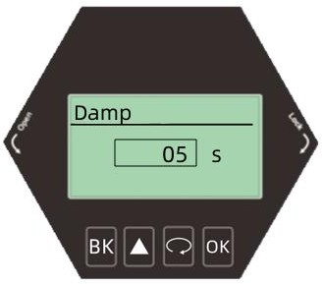
Damping time editing interface Damping time description

Parameter name | Damping time
Parameter range | 0~100
Default | 5
Associated  configuration | nothing
Option meaning | Damping output, improving signal stability
Special matters | nothing

      - Media Type

Enter the [Basic Setting] menu, select [Media Type], press [OK] to enter the container type selection menu
solid
liquid

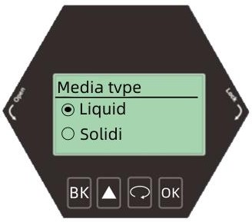

      - Container Type

Enter the [Basic Setting] menu, select [Container Type], and press [OK] to enter the container type selection menu.
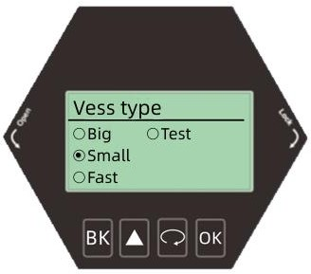

Description of container type
Paramet  er name | Container type
Large warehou  se | This parameter pursues stable measurement output
Kokura | Adapt to most working conditions
fast | Suitable for working conditions requiring rapid measurement
test | 0 delay is suitable for infield test

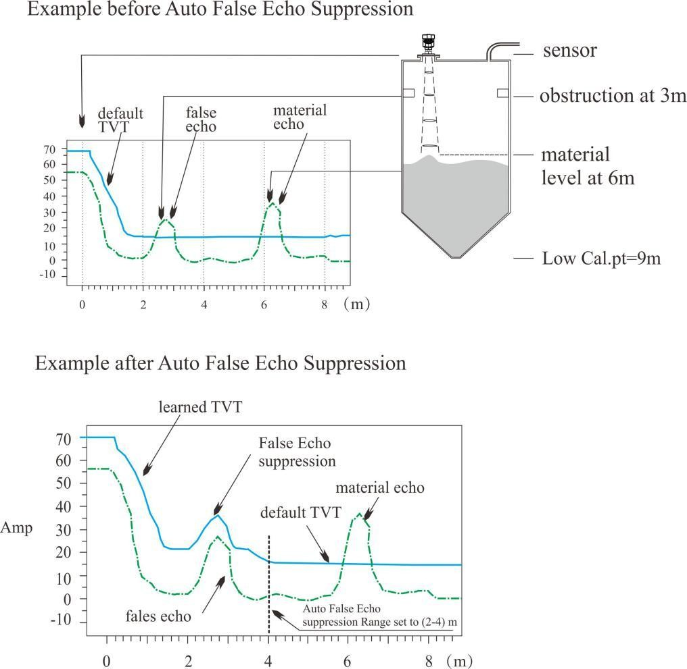
Advanced settings menu operation
      - [False echo learning]

·Press [OK] to enter the basic setting menu bar, and then press [ ] to enter the [Advanced Setting] menu
Press the [OK] key to enter the [False Echo Learning] setting. The [False Echo Learning] can learn the false echo in the container containing known obstacles, and form the background noise screening curve (threshold curve). Before learning the false echo, you need to set the [Threshold Mode] and [Threshold Area].Press [OK] to complete the editing operation, and press [BK] to exit.The display is as
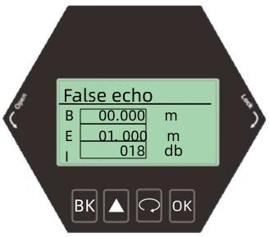
follows:

      - [Distance offset]
·Press [ ] to enter [Distance Offset]
Set [Distance Offset] to correct the deviation between the ideal measurement value and the actual measurement value.The settings have been completed before leaving the factory. Press [OK] to complete the editing operation, and press [BK] to exit.The display is as follows:
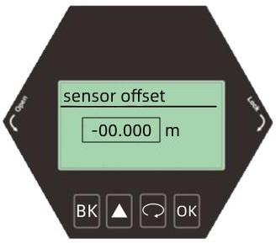
      - [Bus address]
·Press [ ] to enter [Bus Address]
This function is only applicable to RS485 MODBUS communication. When two or more instruments are connected to the upper computer using HART communication interface, this function is required to set the instrument to multi-point working mode.Press [OK] to complete the editing operation, and press [BK] to exit.The display is as follows:
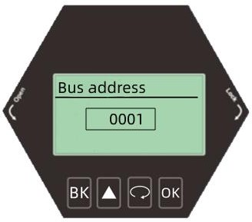
      - [Output Mode]
·Press [ ] to enter [Output Mode]
Select the direction of [Current Output Mode] according to the customer's requirements, press [OK] to complete the editing operation, and press [BK] to exit.

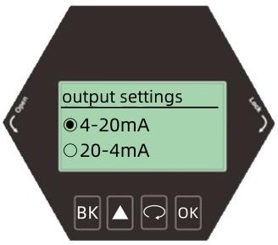

      - [Current simulation]
·Press [ ] to enter [Current Simulation]
Set [Current Simulation] to calibrate the error value of current output, which has been calibrated before leaving the factory. Press [OK] to complete the editing operation, and press [BK] to exit.The display is as follows:
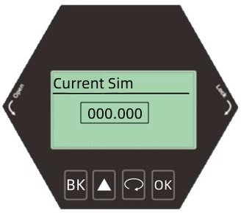
      - Current function
·Press [ ] to enter [Current function]
Set [Current Function] to set the value of actual output current when the instrument encounters wave loss fault.Press [OK] to complete the editing operation, and press [BK] to exit.The display is as follows:
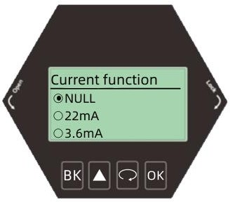

Service menu operation
      - [Echo rate]

Press [ ] to enter [Echo Rate]

[Echo rate] is used to adjust the speed of waveform change. The larger the value, the slower the waveform change, and the more stable the waveform change. On the contrary, the smaller the value, the faster the waveform change.Press [OK] to complete the editing operation, and press [BK] to exit.The display is as follows:
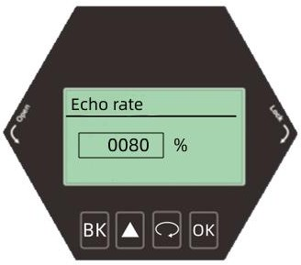

      - Window Settings
·Press [ ] to enter [Window Setting]
[Window Setting] is used to search the front and rear range after waveform locking.After the current echo is locked, it will search for the strongest echo back and forth within the set range value. If the current echo is lost, or the echo of feeding and blanking is too fast, it will search for the strongest echo in the whole process and confirm the current echo.If the previously lost echo is recovered, the previously lost echo will not be confirmed.Time is the speed of arrow tracking.Press [OK] to complete the editing operation, and press [BK] to exit.The display is as follows:
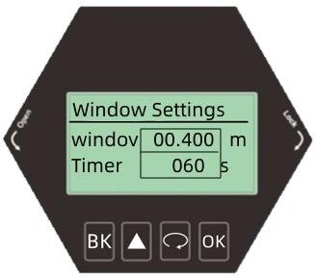

      - [Echo proportion]

Press [ ] to enter the service setting menu option [Echo proportion] The percentage that the echo in the window is greater than the echo in the window
Select the [Service] menu and enter the [Echo Proportion] option. If you need to modify the value, press the [OK] key to complete the editing operation.Press [BK] to exit

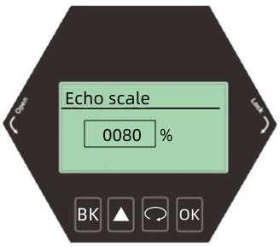
      - [Echo locking]
Press [ ] to enter [Echo Lock]
[Echo locking] If locking is selected, the signal is searched within this window range (here the window range refers to the parameters set in the previous window).If you unlock it, you are looking for signals in the whole process.Press [OK] to complete the editing operation, and press [BK] to exit.It is shown as follows
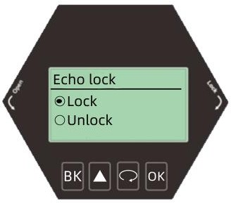

      - [Primary filtering]
Press [ ] to enter [Primary Filtering]
[Primary filtering] In the small range measurement environment, you can choose to turn it on or off according to the waveform.Press [OK] to complete the editing operation, and press [BK] to exit.The display is as follows:

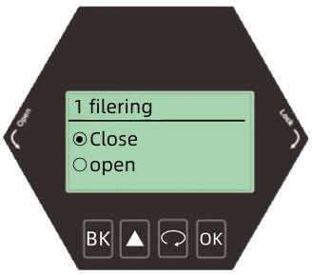

      - [Secondary filtering]
·Press [ ] to enter [Secondary filtering]
[Secondary filtering] means that the interface filtering can be turned on or off according to the waveform in a large range measurement environment, and should not be used if the blind area is too small.Press [OK] to complete the editing operation, and press [BK] to exit.The display is as follows:
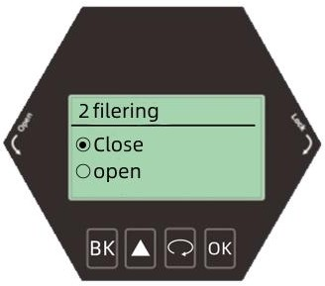
      - [Response rate]
Press [ ] to enter [Response Rate]
[Response rate] is used to adjust the response rate of the instrument to the increase of the actual material level. When the rate and time settings change, the response rate automatically changes.Generally, the solid rate is set slightly higher and the liquid rate is set slightly lower.Press [OK] to complete the editing operation, and press [BK] to exit.The display is as follows:

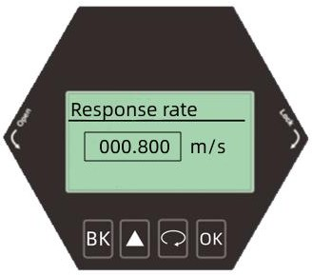

      - Threshold Setting

Press [ ] to enter [Threshold Setting]
[Threshold setting] Set the threshold value of the effective echo. The larger the threshold value is set, the stronger the amplitude of the effective echo on site is required, which is conducive to eliminating the interference of small signal clutter.Press [OK] to complete the editing operation, and press [BK] to exit.The display is as follows:
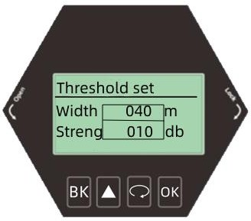

Display menu operation
      - Display Mode
·Press [ ] to enter [Display Mode]
Set [Display Mode] to display three modes of empty height ratio of material level. Press [OK] to complete the editing operation, and press [BK] to exit.The display is as follows:
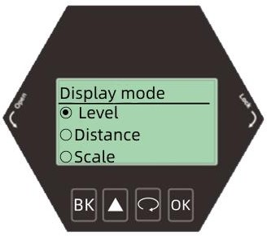
      - [Unit of measurement]
·Press [ ] to enter [Measurement Unit]
Change the unit as required. The default unit is m. Press [OK] to complete the editing operation, and press [BK] to exit.The display is as follows:
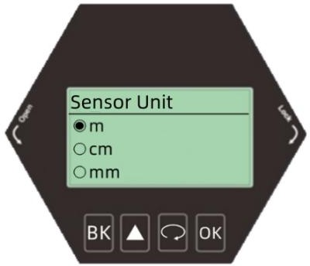

6.4.4.4 [LCD contrast]
·Press [ ] to enter [LCD]
Set [LCD] to adjust the brightness of the display screen. Select [LCD], press [OK] to complete the editing operation, and press [BK] to exit.The display is as follows:
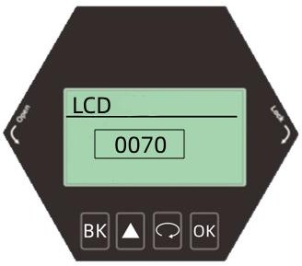

Appendix:Glossary
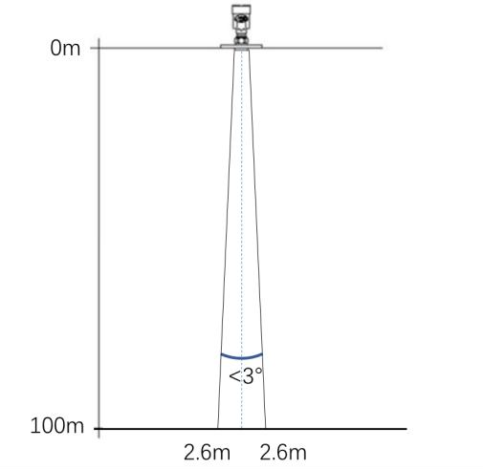

Beam angle: the beam width bounded by 3dB lower than the maximum value.The minimum beam angle is 3 °, as shown in the figure.

Range Resolution: Range resolution refers to the ability of radar to distinguish two objects close together.If the distance between two objects is less than the range resolution of the level radar, then the radar can only measure one distance value, which is not equal to the distance value of any one of the objects, but a combination of the distance values of the two objects.FM bandwidth B=5.1GHz, minimum distance resolution=C/2B ≈ 3cm.
Accuracy: if there is only one object and the object moves a small distance, whether
the level radar can recognize the distance change.The index to distinguish the moving distance of a single object is called accuracy.The IF signal of is analyzed by its own algorithm, and the measurement accuracy is 0.1mm.

Ambient temperature: the temperature of the ambient air in contact with the equipment enclosure.
Blind zone: refers to the measurement limit at the near end of the instrument. The instrument in the blind zone cannot measure
DB (decibel): unit representing signal amplitude.
Dielectric constant (DK): the ability of dielectric to store electric energy under the induction of electromagnetic field.It is often called the relative dielectric constant.The increase of dielectric constant is directly proportional to the increase of echo amplitude.The relative vacuum/dry air dielectric constant is 1.
Echo: Reflected signal received by radar.
Transmission cone: extension of antenna beam angle.
False echo: any echo not generated by the desired target.In general, false echoes are generated by obstacles in the container.
Multiple echoes: multiple reflected echoes occurring at the target echo distance may be two or three times.
Polarization: attribute of emitted electromagnetic wave, describing the direction and amplitude of electric field vector that changes with time.
Range: (1) refers to the farthest measurement limit of the instrument; (2) special refers to the manually set farthest distance, beyond which the instrument will not consider when processing data.
Repeatability: the deviation degree of the measurement results of the same reflection target measured multiple times under the same test environment.
Speed of light: symbol C, speed of electromagnetic wave (including electromagnetic wave and light in free space.) The speed of light is 299792458 meters per second.
Threshold curve: a curve that changes with time. As the threshold value, the echo exceeding it is considered valid.

